**Creating Consistent Client Experiences**

By David L. Lawrence

As a financial practice grows, a point will be reached in which the practitioner may wish to consider developing ways to categorize his/her clients to identify profit levels on a per client basis. Even more important, is identifying service levels associated with those same clients. It simply does not make sense to offer the same level of service to a client who has placed small amounts of investable dollars with the advisor versus one who has invested millions with that same advisor. Therefore, methods need to be devised for identifying and then carrying out service levels that match the client’s needs and are cost-efficient for the advisor.

Some advisors have used a system consisting of such names as Platinum, Gold, Silver and Bronze as categories and then assigning Asset under management (AUM) levels to each of those categories. However, this may not go far enough in fairly delivering services to those clients who may not exactly fall into one or another category. So, how can a financial advisor develop a system of categorization that fits the unique characteristics of a diverse array of client types and/or service deliverables?

The first and most fundamental step is to analyze the client base. By creating a spreadsheet (for instance) that shows how many clients fall into different levels of AUM, fees or planning retainers, it may be possible to uncover breakpoints that can later serve as the criteria for categorization. Here is an example:

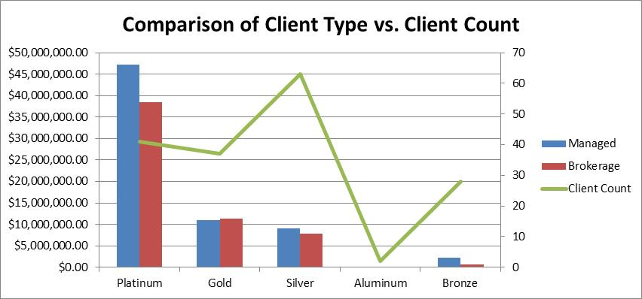

The above example shows a comparison between identified client categories (which platinum representing the highest AUM) and client count per category. This type of analysis can reveal some surprises. As can be seen above, the silver category has the third lowest investable asset numbers, yet has the highest client count. The platinum category, which contains the highest levels of invested assets, is barely in second place in client count. In this example, the financial advisory firm had created these categories, but then split out of each category those clients who had managed accounts versus those who had accounts placed through a brokerage firm (custodian). The feeling was that fees from these two account types should be reflected in the service levels. And, while there does seem to be a correlation between the two account types, there is very little correlation between the AUM categories and the client count, which suggests that this firm needs to better understand where their clients are coming from and to focus on that sweet spot. As an example, the silver category above shows the highest number of clients for the firm, but is only third in the amount of potential fee revenue for that same firm. In other words, the amount of time and resources used by the firm to serve the needs of this group is likely to be much higher than the other categories unless some way is developed to match the services to the client category.

What makes this difficult is if that firm had not adjusted services levels in the past and is now imposing those levels on existing clients, which could have the effect of losing clients who were enjoying higher levels of service. Thus, a line-in-the-sand approach might be warranted. This is where the firm decides to adjust service levels appropriately, but only for new clients. While this has a minimal effect on increasing net profitability in the near term, it may preserve the existing clients.

Another step in this process of client categorization is to find ways to deliver the appropriate service levels on a consistent basis. For this, a full-featured client relationship management (CRM) software is recommended. By full-featured, we are talking about a software platform that has the ability, not only to categorize clients, but establish workflows and have other ways to ensure the delivery of consistent client experiences. While there are a few that approach this fairly well, two worthy of mention are Redtail ([www.redtailtechnology.com](http://www.redtailtechnology.com)) and Junxure ([www.junxure.com](http://www.junxure.com)).

Some time ago, I visited a financial advisors office and while I was waiting in the reception area, I noticed one staff member walking into a small conference room with a tray of items that included coffee, cookies, writing instruments and other items. I asked what the tray was for and the staff member told me that they had developed a set of personal items that their clients like, inputted it into their CRM and then made sure that those items were available in the conference room when the client(s) arrived. This staffer mentioned to me that she once brought an iced tea into a client meeting for the client and then joked, “What? No umbrella?” From that moment on, each time he returned for a client appointment, his drink always had an umbrella. He called her his umbrella lady.

The point of this story is that, by using their CRM to categorize the client and also to identify personal interests, they could ensure that the client experience was exceptional and noticed. It was also easy for the staff to deliver those kinds of touches. Granted, this is a small example. But, if this extends to all types of service deliverables, then it can have a remarkable effect on the client’s perception of the firm and its services.

Sometimes, it is the little things that count. Having accurate records in a CRM can lead to the delivery of superior services as well as lead a client to think he or she is the only client you have. Taking notes and then placing those notes in the CRM for future reference, making promises and delivering on those promises ahead of time can simply add to the WOW factor.

The CRM can be used to ensure consistent delivery of services by automating workflow task steps, assigning tasks to the appropriate people in the office and ensuring accountability for those tasks being completed correctly and on-time. Redtail (for example) has a variety of ways in which a financial advisor can customize the client record to be able to deliver consistent client experiences. With Redtail, you can use the Personal Interests field, the Keywords field or develop your on field (user defined field) to customize the database to fit the way you want to be able to retrieve information through a sophisticated search function. Moreover, you can then save those same search criteria in a Quicklist, which can then be used in the future to pull up an accurate list of clients based on the saved criteria. And, while this example points to Redtail, there are a number of other CRM solutions that can do something similar to this. Junxure, ProTracker, Salesforce, MS Dynamics, eMoney Advisor and Interactive Advisory Software are some of the better known names. However, there is a slew of new solutions to consider as well. Evervize ([www.evervize.com](http://www.evervize.com)) and Advisor’s Ally (<http://www.advisorsally.com/>) are two new solutions you may wish to check out along with the others listed here. The key is finding which CRM contains all of the features that match the needs of the financial advisor’s practice. Even more important is to use those features to create the highest levels of efficiency, productivity and net profitability.

David L. Lawrence is Founder and President of [**EfficientPractice.com**](http://www.efficientpractice.com/)**,** a consulting firm that provides financial practices, broker dealers and independent firms with comprehensive, profit-driven efficiency consulting and resources. He is also the author of **The Efficient Practice: Transform and Optimize Your Financial Practice for Greater Profits and Success**, available at Wiley.com and other book retailers.