**Efficiency Time Management**

**By David L. Lawrence**

One of the challenges of running a successful financial advisory practice is managing time. There are 168 hours in a week, which may sound like a lot, but if used unwisely can be surprisingly short. Of those 168 hours, approximately 56 hours needs to be subtracted for sleep time. Meals can take away another 20 hours a week. And personal maintenance (showers, doing laundry and other personal activities) can absorb another 17 hours or so. Subtracting time for office commute, travel to client’s home or office, etc. can result in as little as 50 hours left in a typical schedule that can be devoted to work activities. Therefore, misusing that remaining time can become a critical issue for firms looking to increase their efficiency, productivity and net profitability. The key is to first understand how your time is being used and then to determine ways in which you can improve your time management.

Examples are plentiful in misusing time. Some financial advisors constantly interrupt their day with the reading and responding to emails. Others may find distractions in the office (visual or auditory interference). Studies have shown that when interrupted from performing an analytical task, it can take anywhere from 10 to 20 minutes to mentally get back on task (other studies have pointed to higher amounts). Multiply this times the number of interruptions in a given day, times the number of affected employees, times the number of work days in a given year and you end up with a serious impediment to efficient office operations.

Here are five myths of time management:

1.) **“There’s just never enough time to get it all done.”** Not true! Managers try to do too much in too little time because they do not prioritize their work tasks.

2.) **“It isn’t necessary to write out your daily and weekly tasks.”** Not true! Creating action lists helps you to set objectives, identify priorities, and focus your time on what is important.

3.) **“We can make more effective use of time if we clean up the small, simple tasks before tackling major projects.”** Not True! The small and simple tasks give us an excuse not to start the larger projects that we perceive as difficult and time consuming.

4.) **“We can’t plan for ‘time bombs’; jobs that end up on our schedule threatening to blow up the whole day.** Not true! We should always build contingency time into our schedules and ensure that our tasks are not completed at the last minute.

5.) **“Others generally impose on us things that waste our time.”** Not true! Others impose work on us because we don’t know how to say “no”.

Face-to-face interruptions account for one-third more intrusions than emails or phone calls, according to a study cited in the Wall Street Journal (Sept. 10, 2013). The article also pointed to a higher rate of interruptions with open office designs (cubicles) over private offices. Error rates can be significantly higher following such interruptions which can cost financial advisory firms money. Yet, office designs with a cubicle arrangement are still popular. Cubicle wall heights are shorter, which contribute to interruptions.

So the question is, what can financial advisory practices do to cut down on such interruptions and improve overall time management and efficiency? Actually, there is quite a bit that can be done to improve on these issues. And, it does not have to cost a lot to achieve it. Here are a few tips to improve time management and efficiency.

One concept for time management is to create a schedule template. This is a framework for a typical week with blocks of time devoted to different tasks, such as reading and answering emails, appointments, analytical time and the all-important me-time. Here is an example:

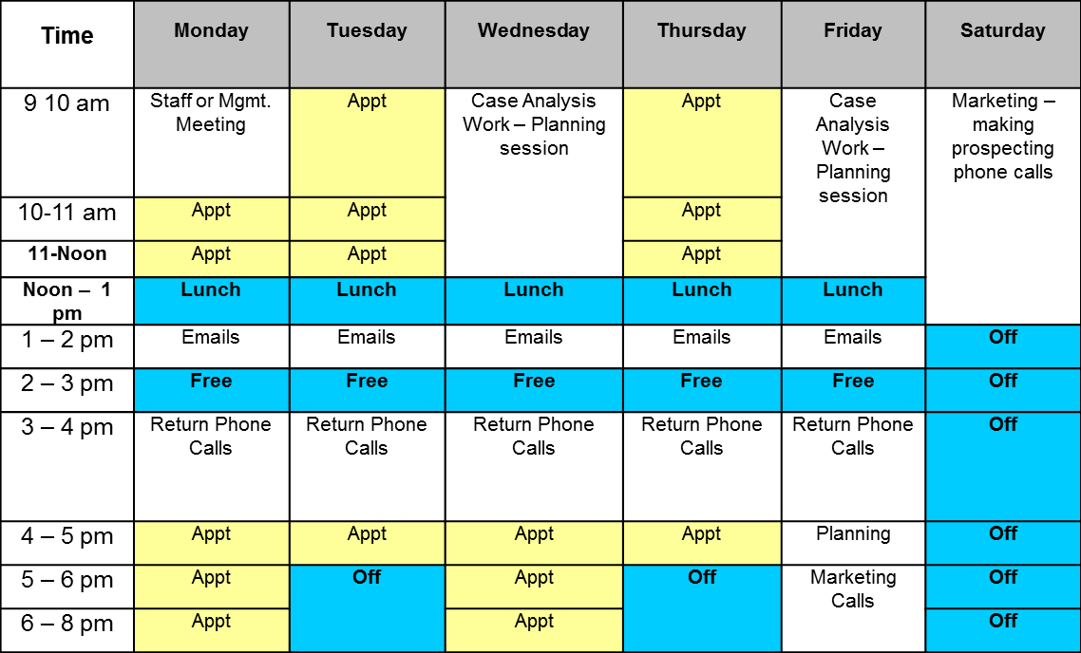

The concept is not intended to be strictly followed as there are always exceptions to account for. However, if a financial advisor and/or his/her staff use this as a guide, productivity and efficiency can be significantly increased. Many client relationship management softwares allow you to input recurring activities into the software’s task/activity feature and/or calendar function. It may be possible to overlay the schedule template so that everyone in the firm is on the same page when it comes to scheduling activities, appointments, etc.

Delegating tasks to the appropriate person is a key skill for any business owner. For financial advisors who have spent much of their earlier careers doing it all themselves, this is a difficult skill to master. But, ask yourself if it makes sense for someone earning around $450/hr. to be entering basic information (client’s name, address, phone numbers, etc.) into a software versus an administrative person earning $20 or so an hour.

Avoid multi-tasking! Yes, that’s right, avoid it. Some feel that multi-tasking is an efficient way to get things done. But, the truth is that we can complete an analytical task faster and more efficiently (and accurately) when our focus is solely on that task. Multi-tasking is often a misleading concept. If, for example, you are working on the recommendations for a financial plan for one of your clients and you are interrupting yourself to read emails or take a phone call (for instance), the analytical task will take significantly longer to complete and you run the risk of blatant errors in the final product.

Learn how to say no! Some advisors feel that if they don’t jump every time a client wants their time, they will lose business. But the truth is, allowing clients to step on your time, often for non-emergencies, is telling those clients that your time is not valuable. Ultimately, this message could lose you more business than if you are communicating to your clients that your time is valuable. This is not to say that you always say no to requests from clients for your time. But, ensuring that on those occasions when your time is used out of the ordinary, it is for valid reasons (i.e. a true client emergency, etc.). True efficient time management requires discipline and commitment. Remember that ‘time is money, efficiency is life’ (quote from Yuan Geng, Chinese philosopher).

David L. Lawrence is Founder and President of [**EfficientPractice.com**](http://www.efficientpractice.com/)**,** a consulting firm that provides financial practices, broker dealers and independent firms with comprehensive, profit-driven efficiency consulting and resources. He is also the author of **The Efficient Practice: Transform and Optimize Your Financial Practice for Greater Profits and Success**, available at Wiley.com and other book retailers.