**Efficient Delegating**

By David L. Lawrence, RFC®, AIF®

Clearly, one of the greatest challenges for financial advisors is managing time. Efficient use of time is often a confusing issue as there are many opportunities to mis-use one’s time. Yet, often it is the lack of sufficient time that leads to the greatest frustrations in a financial advisor’s career.

As financial advisors spread themselves ever thinner, tackling from three to six different roles, on average, efficient time management becomes harder and harder to achieve. A new study by Mavenlink ([www.mavenlink.com](http://www.mavenlink.com)), for example, shows that one in four small business owners believe each productive hour in a day is worth upwards of $500. Yet, those same business owners are often seen doing tasks that could have been delegated to another employee at a far lower cost per hour. For financial advisors, such time demanders could be tasks such as:

* Excessive and un-prioritized email reading
* Surfing the internet
* Doing financial plan inputs
* Filling out forms
* Looking up data online
* Etc., etc., etc.

Other surveys have pointed to the increased burden placed on these advisors in recent years, including one by Sage Small Business that found small business owners are not only working harder than they were five years ago, they're also working longer hours. Another survey by Citibank found that owners are sacrificing their pay as well as family or vacation time, in addition to working those longer hours.

These studies seem to confirm an earlier study by Rough Notes (www.roughnotes.com) as shown in the graphic below:

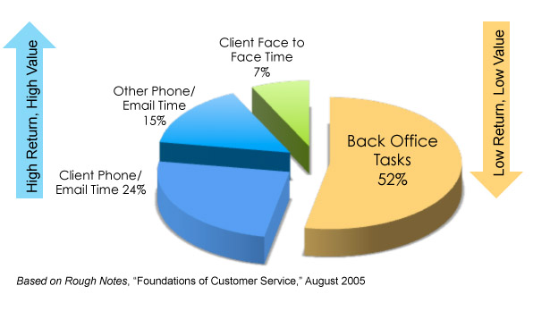

As can be seen from this graphic, more than 50% of time in any given work day is eaten up by back office tasks. The irony of the above graphic is the most valuable use of the financial advisor’s time, generally regarded as face-to-face time with the client, represents the smallest percentage of overall time. Often, the reason why this is true is because of a lack of proper delegating. With efficient delegation techniques in place, a firm could free up significant amounts of time, increase the capacity of the firm to accept new business (without necessarily having to hire more people or increase expenditures), and greatly increase the firm owner’s personal time.

One way to get a handle on how your time is being used (or abused) is to keep track of what you do for a typical week. There are a number of ways to do this, from keeping a notebook to utilizing time tracking software (some are available for smartphones, for instance). The point is to be truthful and accurate in studying how you spend your time at work. And, the goal is to uncover things that you are doing that perhaps you should not be doing. Most of us are guilty of taking on tasks that could be handled by someone else.

Therefore, one of the most effective ways to manage a financial advisor’s time is through the use of efficient delegating of tasks. As your business grows, you may find that in order to continue to move forward, you need to start handing over some of your daily to-dos to someone who can get the work done and free up your time for other, higher-level business activities.

But although it may be necessary, delegation can be a very difficult step for many financial advisors. This may be due, in part, to how they started in the profession, essentially doing it all themselves. With firm growth, this quickly becomes a roadblock to future success. Some of the hurdles advisors may have to jump in order to delegate efficiently include:

* Feeling like they need to do everything themselves to have it done right.
* Not having the time or desire to transfer the knowledge necessary to have someone else take over.
* Being unable to find people they trust enough to delegate to.

While these are all valid and significant hurdles, financial advisors can overcome all of their reservations by taking a well-planned and logical approach to delegation. For this, there are five steps that should be considered:

1. Identify those tasks that should be delegated - In every financial practice, there are some things that can be delegated and others that should not. For example, you should probably avoid delegating tasks that require a higher level of knowledge and/or experience than those that might be delegated to. And it is really important to fully and clearly define what the task is that is being delegated.
2. Make sure you are delegating a task to the right person – developing position outlines for your staff that define their role in the firm is a good first step to identifying what tasks should be undertaken and by whom.
3. Provide clear documentation and instructions – For repetitive tasks, this constitutes a workflow management system or developed task sets. With clear instructions, the employee has a much better chance of completing the task(s) correctly, efficiently and on time.
4. Develop workflow tracking systems – rather than micro-managing your employees use workflow management tools, many are already embedded in client relationship management software, to quickly view what work is in progress in your office.
5. Provide feedback – it is just as important to let your employees know when they are doing the tasks correctly as when they are falling short of expectations. The process of feedback can also uncover gaps in the workflow process and provide clues to improve the system.

By providing your employees with responsibility assigned within the limits of accountability, you create an opportunity for those employees to grow and be more motivated to do good work.

Some financial advisors have paired this technique with a compensation program with individual and team bonuses, based on specific, objective performance criteria. These bonus structures may be developed and paid more frequently (such as quarterly) instead of the old traditional annual bonuses paid out at year-end. Tying bonuses to performance criteria, such as on-time completion of tasks, accuracy, and/or error-free work can definitely tie the firm goals to those of the employees.

Replacing micro-management with effective workflow management systems has the effect of erasing distrust and increasing overall performance standards. And, most important of all, the financial advisor can free up significant amounts of time that can either be re-directed to client facing activities or simply more personal time.

David L. Lawrence is Founder and President of **The Efficient Practice**. Efficient Practice is a consulting firm that provides financial practices, broker dealers and independent firms with comprehensive, profit-driven efficiency consulting, technology solutions and resources. For details, visit [**www.efficientpractice.com**](http://www.efficientpractice.com).