**The Challenge of Workflow**

By David L. Lawrence, RFC®, AIF®

If there is one aspect of a financial advisor’s daily operations that has drawn questions in light of relatively new computer software offerings, it is workflow. Workflow management is a key way to ensure the smooth and efficient operation of a financial practice while permitting staff to accomplish common sets of tasks associated with a workflow. Workflow management systems vary, but one aspect they share in common is the establishment of a series of tasks that generally can be configured to automatically assigned based on the completion of a prior task or workflow task set.

The advantage of these systems is the avoidance of missing steps in a workflow process and/or allowing things to slip through the cracks. Consistency and timeliness in accomplishing sets of tasks, particularly where it involves communications with the client, are important aspects of increasing the profitability and decreasing the costs associated with the practice. The reduction and/or elimination of errors and duplication of tasks is another potential advantage.

So, if it is clear that workflow is such a great benefit to financial advisory practices, why is it not more universally used? One reason may be the complexity involved in developing workflow procedures. Another may be the mis-perception that establishing standardized procedures in a firm detracts from the customized nature of the relationship with the client.

To better understand a apply the concept of workflow to your financial firm, it may be necessary to first understand what workflow is, how it works and what steps are needed to build workflow systems in your office.

One definition of workflow is that a workflow consists of a sequence of connected steps. It is a depiction of a sequence of operations, declared as work of a person, a group of persons, an organization or staff, or one or more simple or complex mechanisms.

The development of a workflow should have at least three steps: 1.) **Strategic planning** step which might include developing a mind map that can sort through all the random thoughts associated with workflows and organize them in some way, 2.) **organizational step** in which a flowchart or other similar tool might be used to depict the flow of activities/tasks/events associated with a particular workflow task set, and 3.) **written steps** in the workflow.

For purposes of illustration, a mind map might look similar to the following:

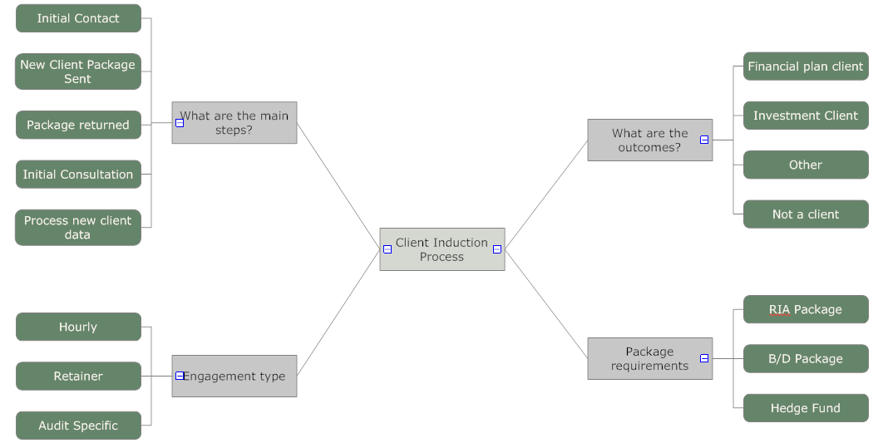

If you do not already have mindmapping software, you may wish to check out [www.mindjet.com](http://www.mindjet.com), [www.mindgenius.com](http://www.mindgenius.com), or the free <http://freemind.sourceforge.net>. If you already own a version of SmartDraw ([www.smartdraw.com](http://www.smartdraw.com)), you may already have mindmapping capabilities. The beauty of mind mapping is the ease with which you can re-arrange blocks of ideas/information/topics to create an organized approach. Once organized, you may wish to transfer this to a flowchart to better understand and depict steps in a workflow process.

Flowcharting is done to illustrate steps in a series of tasks associated with a workflow. There are several flowchart programs that can be used for this purpose, including the aforementioned SmartDraw.

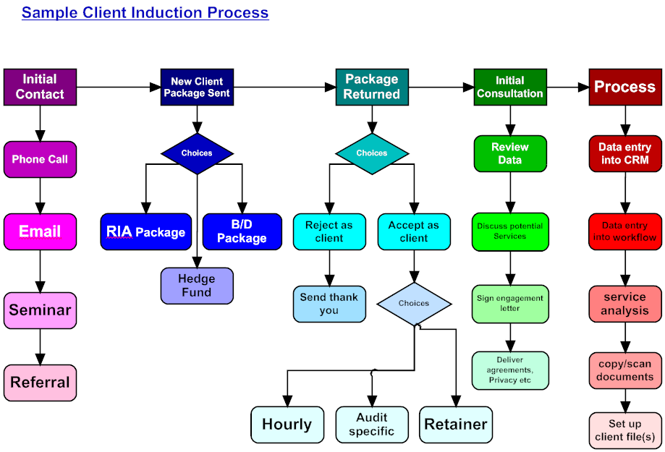

The above is an example of such a flowchart. This particular one shows a variety of different kinds of elements within each task set.

There are at least three possible types of task sets, Sequential, Non-sequential and decision trees. Sequential tasks are tasks that are accomplished one right after the other. In workflow management programs, generally the system ‘fires’ (begins) the next task based on the successful completion of the last task and so on. In non-sequential tasks, you may have several tasks that need to be accomplished all at the same time. This would be where the completion of one task could trigger the automatic assignment of several tasks at once. In Decision trees, what happened in the prior task might determine which of a list of future tasks must then be accomplished and the system could automatically create the appropriate next step(s) based on the how the prior step was completed or determined.

These three typical choices are easy enough, on their own, to understand. The reality of complex workflows though is that a workflow task set very likely could be comprised of several different types of tasks adding to the confusion in developing the workflow. There is also the issue of tying workflows to a database. With some client relationship management software programs (CRM), workflow features are available and can be directly tied to the associated client database. This offers several advantages in that if one needs to check on the status of a workflow for a particular client, it can usually be found in the client’s record. Junxure ([www.junxure.com](http://www.junxure.com)), ProTracker Advantage ([www.protracker.com](http://www.protracker.com)), Redtail ([www.redtailtechnology.com](http://www.redtailtechnology.com)), Upswing ([www.upswingcrm.com](http://www.upswingcrm.com)), Goldmine ([www.goldmine.com](http://www.goldmine.com)), and several others contain workflow features (albeit on differing levels of sophistication). However, workflow is not exclusive to CRMs. There are stand alone workflow programs and workflow features can be found with such document management software as Laserfiche ([www.laserfiche.com](http://www.laserfiche.com)).

Another key aspect of efficiency in the use of workflows is in the management of the workflow process. Most workflow software products have reporting capabilities that can simplify the process of managing people and resources. Having the ability to view a list of outstanding workflows and/or completed workflows can free a manager from having to constantly ask employees what work is going on in the office. Having the ability to generate FYI type emails can also help, however in busy offices this can quickly become a burdensome list of emails for a manager to have to sift over each day. In those cases, generating a dashboard type reporting system or building lists for daily viewing is preferred.

In reviewing the lists, it is quick and easy to spot areas where slowdowns are occurring which can focus a manager’s attention on those items for follow-up and review. It may help in spotting training opportunities or system bottlenecks as well. For the system to work well, managers as well as staff must be trained in how to used it effectively. In the end, how efficient workflow can be in a financial advisor’s practice is going to depend on the buy-in by all parties involved in the process.

At the most recent Technology Tools for Today Conference, held in Weston, Florida on February 16-19th, Workflow was one of the most popular topics on the agenda. According to James Carney, CEO of By All Accounts, software ‘should work like a refrigerator’. By this, he meant that software should be easy to use, work the way it is expected and not require the user to understand how it works as much as that it works. With a refrigerator, we only want to be able to organize it to find things easily and that it keeps our food and beverages cold. We do not necessarily need to know how the compressor works. In workflow software, the goal is to make the process of accomplishing sets of tasks easier and more efficient, as well as simplifying the management process.

David L. Lawrence, RFC®, AIF®, is Co-Founder and President of Global Practice Network, a technology and consulting firm that provides financial practices, broker dealers and independent firms with comprehensive, profit-driven efficiency consulting, technology solutions and resources. Global offers a Collaboration Portal and Advisor Network with tons of resources, articles, templates, and newsletters for its members. For details, visit www.globalpracticenetwork.com.