**Keeping Track**

By David L. Lawrence, RFC®, AIF®

Keeping track of everything that you do and say in a financial advisor’s practice can be a daunting challenge, particularly in offices with staff and/or multiple producers. With a mature firm, typically hundreds of things could be going on that require tracking; from follow-up tasks to managerial oversight of employees.

An efficient financial advisor’s office should be one where nothing slips through the cracks. Follow-ups are done promptly, consistently and accurately. But, the reality is that this is often a difficult goal to achieve. One reason may be a lack of specific techniques to get it done. Another reason could be a lack of persistence on the part of management to keep up with tasks, workflow items, appointment follow-ups and all the myriad other things that can go on in a busy office environment. And, yet a third reason might be a lack of delegation skills to ensure the tasks and follow-ups get done.

Perhaps a good New Year’s resolution might be to develop systems and procedures that help you keep track of everything that is going on in your financial practice. One way to start this process is with planning. Mind mapping is an effective technique that can help organize your thoughts in this area and perhaps begin the process of developing techniques that can be applied in your office. Consider the following mind map, developed using FreeMind ([www.freemind.sourceforge.net](http://www.freemind.sourceforge.net)), a free mind mapping utility.

The following is an example of a mind map that shows a work in progress.

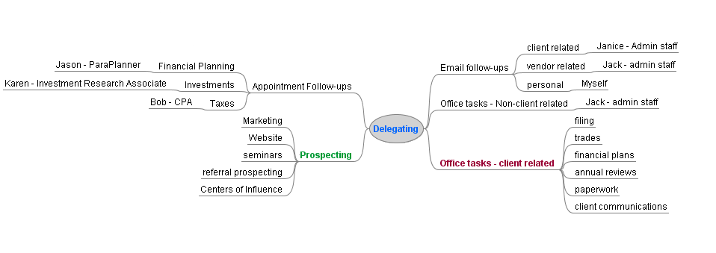

The above sample mind map shows some initial thoughts into the structure of delegating tasks. With most mind mapping programs (FreeMind, Mindjet, Mind Genius, etc.), there is the ability to color code, prioritize and move items around as you try to figure out the structure. The flexibility of the program matches the free-thinking that goes into this type of planning process. In effect, it is building structure out of random thoughts around a central topic or set of topics. And, it can be a powerful tool.

Once the structure is determined, there has to be a methodology to track it all. This is the point where identifying who does what and when is critical. It is important to construct employee position descriptions that are detailed with objective, measureable criteria. With this in place, the next step is to create managerial oversight systems and/or techniques. One major reason for this step is to avoid the impulse to micro-manage your staff. Creating passive ways to observe their work, both from a quality and a quantity standpoint, is preferred as it can not only free up your time, but give your staff the impression that you trust the work they are doing. Delegating work does not mean that you give up control, simply that you free up your schedule. When done correctly, delegation can significantly increase your time efficiency. And, it does not have to result in loss of quality or timeliness of tasks. However, to be an effective delegator, you do have to find ways to circle back with your staff to ensure things got done the way you wanted.

For this, there are two methods worth considering. First is to consider using a workflow management system. If you are worried about the cost, you may be surprised to learn that you probably already own one. Chances are that if you are using one of the more popular Client Relationship Management software programs, it already has a workflow management feature. The most common of these is the ability to pre-build workflow task sets; these are pre-determined steps in a workflow with staff assignments already in place. As each step in the process is completed, the next step could be automatically triggered. With such features, there is usually a way to print reports on the status of pending workflows; a key “passive” way to keep track of your employee’s progress on outstanding tasks. If you do not have a CRM software that does this, you may wish to look into one or consider a separate workflow management tool such as JobTraq ([www.jobtraq.com](http://www.jobtraq.com) for enterprise systems) or Workflow Central ([www.workflowcentral.com.au](http://www.workflowcentral.com.au) free for small businesses).

The other method is to consider using a reminder system. For this, there are several possibilities. First, and probably least efficient, is the use of a notebook. Some practitioners use a spiral bound notebook to jot down notes and reminders in date order and then refer back to the notebook to ensure that they do not overlook anything. While this is, in essence, an inefficient method, there is an electronic version of this called Microsoft One-Note. One-Note is now available with some versions of the new Microsoft Office 2010. Emulating the old paper version of a notebook, you can create notebooks, sections of notebooks and separate pages, all organized by topics, titles, subjects, dates, etc. The beauty of this new version is the ability to attach a note to an email or other document and share it with a workgroup or other person. There is also a version for mobile devices with expanded capabilities over prior versions.

Another reminder technique is to use a reminder service. For this two come to mind; Jott.com and Nudgemail.com. Jott is a nifty service where you call a number and an automated service asks who you want to jott and then what you want to jott. By answering yourself and then giving a message, the result is an email generated and delivered to your inbox or mobile device reminding you. This is a clever way to keep track of things when you remember something and you are nowhere near your office or staff. Simply jott one of your employees or yourself and the reminder is captured. At least one of the more popular CRM software programs has integrated Jott into its program ([www.redtailtechnology.com](http://www.redtailtechnology.com)).

NudgeMail is yet another way to provide reminders. With Nudgemail, you simply write or forward any email to NudgeMail, and it will send it back to you when you want it. Is your Inbox clogged with stuff you really need to follow-up on later? NudgeMail lets you set reminders by the hour, day, week, month, or even year so you can decide when to deal with important emails. NudgeMail works with most email services and most mobile devices. Oh, and by the way, it is free.

No one method of keeping track is likely to be enough, for most firms. But, by experimenting with those listed above and others, it may be possible to assemble a set of tools that match your needs and in the process keep track of things in a more efficient manner.

David L. Lawrence, RFC®, AIF®, is Founder and President of EfficientPractice.com, an operational efficiency consulting firm that provides financial practices, broker dealers and independent firms with comprehensive, profit-driven efficiency consulting and resources. EfficientPractice.com offers an Advisor Network with tons of resources, articles, templates, spot coaching and newsletters for its members. For details, visit [www.efficientpractice.com](http://www.efficientpractice.com).