**The Art of Collaboration**

By David L. Lawrence, RFC®, AIF®

Collaboration is defined as the act of working together with one or more people in order to achieve something. Teamwork could be another definition. Most definitely, collaboration is the effort of many to build a result that the whole is greater than the sum of its parts. In translating this concept to the financial profession, there are many unique ways to build and function in a collaborative environment. Beyond the mechanics, there are literally ‘game changing dynamics’ that collaboration can produce.

To explore this concept, interviews were held with three very different firms on their use of collaboration in working with clients. The first of these firms is:

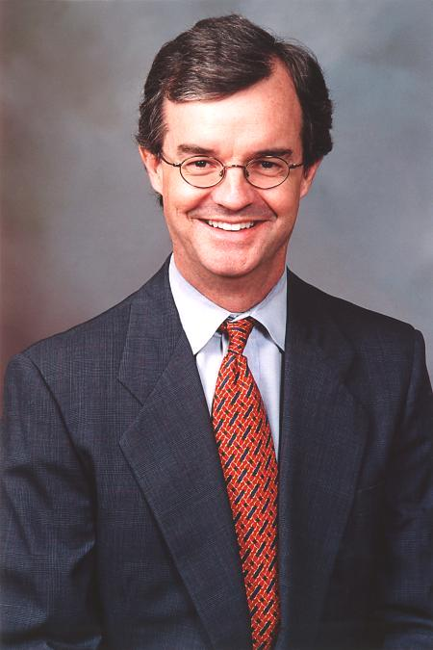**Charles D. Haines, LLC (**[**http://charlesdhaines.com/**](http://charlesdhaines.com/)), a financial practice located in Birmingham, Alabama. Charles, listed as an MBA, CFP®, is a member of the Financial Planning Association (FPA) and a founding member of National Advisor’s Trust. He uses both organizations for collaboration. He describes his practice as ‘life planning on steroids’. One interesting aspect of his practice involves collaboration with a Licensed Clinical Social Worker, who is also an assistant professor at a local university. He refers to the collaborative work as having developed a specialty in ‘Family Systems’. “The family system” , Charles says, “similar to a biological system, is one where if one part of the system is affected, the rest is affected too. Thus, exploring the impact of family dynamics on estate planning decisions is crucial to the process.”

Charles D. Haines, MBA, CFP®

According to Charles, “we are successfully merging family psychology and money.” And, he refers to money as frozen energy that can be a negative or positive force depending on how it is handled for the next generation. For wealthy clients, the firm uses the Heritage Process™ ([**www.theheritageinstitute.com**](http://www.theheritageinstitute.com)).

To facilitate the collaborative process, Charles has developed a verified family package (that provides balance sheets, information on and about the client, etc.) that he uses with collaborators. He utilizes WEBEX online video conferencing as a communications portal with those collaborators.

Charles also stresses the importance of collaboration with other advisors in established study groups. He is a member of the Alpha Group (20/20) and uses that venue to share due diligence ideas, management techniques, etc.

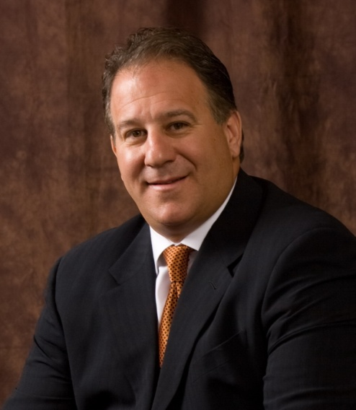Additionally, he has made use of the FPA’s college intern programs, hiring two of those interns as permanent employees following their internship. In short, Charles D. Haines, LLC has found that collaboration can work in a number of divergent ways to positively impact the overall practice and provide expanded services to clients.

The second firm is: **Integrity Wealth Management** ([**www.integrityiwm.com**](http://www.integrityiwm.com)) located in Newport Beach, California. Integrity is headed up by **Ralph G. Adamo, CFP®, CLU®, CHFC®, CAP®**. Ralph founded the Institute for Advisor Advancement, which is a platform for advisors and others to learn how to collaborate and to develop relationships with fellow collaborators.

Ralph G. Adamo, CFP®, CLU®, CHFC®, CAP®

The Institute is a brainchild of how to make a footprint in the collaboration space. Power partners are other advisors, bankers, CPAs ,etc. Ralph points to this as a high touch organization. He hosts community events to provide entertainment, sharing of ideas, problems and solutions.

His firm works in both non-profit and for-profit areas. In the non-profit area, he chose to become a subscriber of the Donor Motivation process, through the Institute for Family Wealth Counseling ([**www.institutefwc.com**](http://www.institutefwc.com)).. This institute (separate from the Institute for Advisor Advancement) helps to develop the reason for gifting, etc. The institute’s program takes advisors and their clients through the mental calisthenics of the gifting process to create a win/win situation for all who are involved.

Ralph strongly believes in the importance of collaboration through community involvement. He serves on the advisory council at Choc Children’s Hospital in Newport Beach ([**www.choc.com**](http://www.choc.com)). He chose to join the council because of his work in the philanthropic arena. However, the value-added benefit has been to develop relationships with the other council members, many of whom have become collaboration partners in his financial practice.

In addition to his volunteer work with the Children’s hospital, Ralph also donates his time with the local FPA Chapter in Orange County, California as a board member. He has found that the people he has met through that role have been invaluable to identifying and developing potential collaboration partners for his firm.

Ralph also mentioned that, in California (unlike many other States), CPAs can participate in profits with collaborations with financial advisors. This creates opportunities with profit motives for potential collaboration partners. As he put it, “they can connect with an economic glue.”

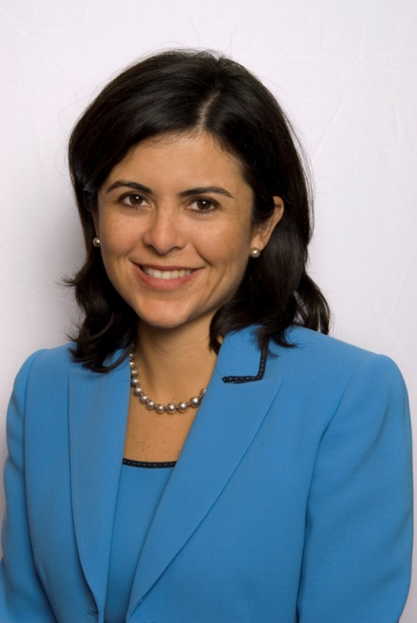The third firm is **Gibraltar Private Bank & Trust (**[**www.gibraltarprivate.com**](http://www.gibraltarprivate.com)**)** in Coral Gables, Florida. Its Director of Financial Planning is **Elaine King, CFP®, CDFA™**. Ms. King is a member of the Institute of Divorce Financial Analysts, The FPA, Miami-Dade Chapter (currently the Chapter President), the **International Academy of Collaborative Professionals** (IACP) and serves on the Board of the Collaborative Family Law Institute.

Elaine King, CFP®, CDFA™

Elaine is a Certified Divorce Financial Advisor who specializes in the Collaborative Divorce Process. She describes this as “...a process where attorneys, mental health professionals and financial planners get together with the goal of having a better experience (...for the respective clients)”.

In her practice, the collaborative discipline consists typically of two attorneys, one financial planner and one mental health practitioner. Elaine’s collaboration group, which could additionally include forensic accountants, business valuation specialists and even estate planning attorneys meets once a month to discuss issues and to share referrals.

The common thread among all three of these firms is the commitment to community involvement and the use of outside organizations and affiliations to promote and enhance the collaborative experience. It was clear from conversations with all three of the above individuals that their involvement in other organizations was not solely self-serving. They all expressed that the involvement was borne out of a desire to learn, to grow and to help others. The subsequent collaboration opportunities were an added bonus.

Surprising among all three firms was the absence of advanced collaboration tools. None of these three firms were using collaboration features inherent in financial planning software (for instance), such as the features found in Naviplan ([**www.naviplan.com**](http://www.naviplan.com)) or MoneyGuidePro ([**www.moneyguidepro.com**](http://www.moneyguidepro.com)). Neither were they using collaboration portals such as the Family Office Network ([**http://www.familyofficenetwork.com/**](http://www.familyofficenetwork.com/)), Junxure’s ClientViewTM Live ([**www.junxure.com**](http://www.junxure.com)) or Advisor Products Personal Client Portals ([**www.advisorproducts.com**](http://www.advisorproducts.com)).

Also missing was any mention of social networking sites such as Facebook, Twitter or others. Professional networking sites such as LinkedIn or Plaxo were also not mentioned. The conclusion that could be reached from this is that face-to-face communications, in the development of collaborations, is preferred over such services. While patently inefficient on the front-end, the results may very well make up for it.

David L. Lawrence, RFC®, AIF®, is Founder and President of EfficientPractice.com, an operational efficiency consulting firm that provides financial practices, broker dealers and independent firms with comprehensive, profit-driven efficiency consulting and resources. EfficientPractice.com offers an Advisor Network with tons of resources, articles, templates, spot coaching and newsletters for its members. For details, visit [www.efficientpractice.com](http://www.efficientpractice.com).