Migrating Advisors: The Challenges of Changing Your Broker/Dealer Relationship
By David L. Lawrence

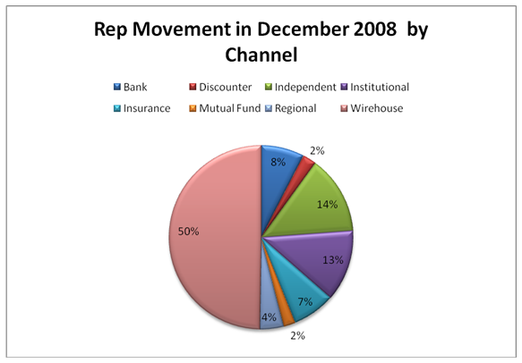
According to a ongoing study by Discovery Database, an average of 2,000+ advisors change Broker/Dealer relationships each and every month. For some of these, movement was within the same channel (wirehouse, independent, regional, bank, insurance or institutional). For others, movement was clearly outside of their existing channel. In December of 2008, of all Registered Representatives that relocated, 50% moved out of the wirehouses. While a staggering statistic, it is hardly surprising considering what has occurred in the wirehouse channel in the latter part of 2008.

What makes this set of statistics interesting is the enormous challenges faced by those wirehouse reps who choose to move into the independent channel. Recognizing the opportunity presented by this migration, several independent Broker/Dealers have developed marketing programs designed to appeal to such people. Firms such as LPL, Cambridge Investment Research and Raymond James (among others) have positioned themselves as transition partners to those reps who choose to leave the wirehouse world.
The reality is, most have enjoyed years of high end back office support typically lacking in the independent world due to the economics involved. The independent advisor is expected to create their own support systems, for the most part. So, the independent B/Ds have in many cases built flexible platforms that offer choices to advisors on the level of support they might ultimately choose to pay for. Raymond James, for instance has four distinct channels for advisors to choose, relative to payout levels and support systems. And, within the four, particularly the fully independent channel, there are additional avenues of support that can be integrated into the package. This type of flexibility may be attractive to a former wirehouse broker who lived in a world where compliance, trading, statement generation and other back office duties were typically handled by others.
However, this is by no means the only challenge faced by such advisors. The changing face of financial services has created challenges for advisors on all levels, not the least of which is the specter of distrust engendered by falling account values. Clients are more likely to question the motives of their financial advisor given the meltdown of the financial markets. And while it may be appealing to create a fee-only financial advisory firm and point out the relative lack of bias with such a firm, the mere fact that that same advisor came out of the wirehouse world (commissions) could make the transition and retention of client assets after the transition that much more difficult. Research studies have shown that, on average a financial advisor migrating from one firm to another will retain around 68% of the assets under management (or clients). This number is likely to be somewhat lower given the level of client dissatisfaction. Clients may ultimately move from a firm, but may choose a different advisor.
So the question is, if an advisor is considering a change into the independent world, what can he/she do to migrate successfully and retain the highest number of clients and/or assets under management (AUM)? The answer lies in planning and forethought. To be successful, the advisor needs to spend an inordinate amount of time (and potentially money) on planning a transition campaign. Several aspects of such a campaign need to be included in the planning process.
- Where are you going to go? Simply deciding to leave is not enough. The advisor needs to consider the world in which the new practice will reside, be it independent broker/dealer, independent Registered Investment Advisor or other. For the independent broker/dealer, there is the potential advantage of support systems but the inevitable disadvantage of lower payouts. For the Registered Investment Advisor, there is the advantage of higher payouts but the disadvantage of undertaking all back office duties, compliance responsibilities, etc. It really should come down to style. What style of business does the advisor want and how much control over the style do they require? If true independence is desired, this might be the choice, but be prepared for the startup costs and responsibilities involved. Size matters! If an advisor has $25 million or less of AUM to transition, it may not be financial feasible to take this independent RIA route alone. It may be wise to look into merging with others.
- How do you get started? A properly planned transition could take months to pull off successfully. Prepare for this. Use that time to explore all your options, line up your technology, office space, human resource and outsource provider needs. Membership Associations such as the Financial Planning Association (FPA), The National Association of Personal Financial Advisors (NAPFA) and the International Association of Registered Financial Consultants (IARFC) have tons of resources available to their members on becoming independent. Most are freely available or discounted to members. Use this information!!
- Who do you ask for advice? There are a number of external consultants that may prove useful in this transition process. Working with a consultant that focuses on building your ADV (State and/or Federal registrations) is essential. Shop around! There is a number of these out there and prices vary for the same services. Use a technology consultant to make sure you are spending wisely on the technology you need and not what someone else thinks you ought to have. Contact an operations consultant that can help you structure your internal operations, staffing needs, office space requirements, etc. And, you may also need legal advice on your firm’s corporate structure, selling agreements, engagement letters, etc. All of these external consultants can work with you well in advance of your planned move.
- Build a detailed timeline building up to the go-live date. Part of business planning involves specific time goals to accomplish various aspects of the transition process and should be part of a detailed timeline. This permits everyone involved in the project to be on the same page with respect to the end result and the dates associated with getting there. It is absolutely critical to have the pieces of the puzzle fall into place when planned, in effect a predictable pattern to the transition process.
- Build a communications campaign. This is actually one of the more difficult tasks to accomplish. On the one hand, you want to keep your clients in the loop on your plans. On the other hand, there may be specific restrictions on what your current broker/dealer will allow you to say to clients. Make sure you fully understand what you can and cannot communicate to your clients, verbally, in writing or otherwise. But, effective and timely communication with your clients, preparing them for the eventual transition, will be the most impactful means of retaining those clients and their investment assets.
Ultimately, how thorough you are in planning this transition will govern how successful the process is. The measurement of success may be in the retention numbers or in the look and structure of the new firm. For some, it may be as simple as the feeling of independence and doing what is right for the client.

David L. Lawrence, RFC®, ChFE® is a practice efficiency consultant and is President of David Lawrence and Associates (DLA), a practice-consulting firm based in Tampa, Florida. DLA publishes a monthly subscription newsletter, “The Efficient Practice”, which focuses on operational efficiency. (www.EfficientPractice.com) and hosts The Efficient Practice Advisor Network. He can be reached at dLawrence@efficientpractice.com.

