Information Security: Keeping Private Information Private
By David L. Lawrence, AIF®

In this age of malicious software embedded in websites and spam email, email phishing, identity theft, electronic eavesdropping, computer viruses, and other means of stealing information, it would seem obvious to most financial advisors that taking steps to protect client and firm data would be warranted. Yet, many firms still do not take these threats seriously, leaving information openly accessible to anyone who happens to wander by.
Let’s take one case in point. An advisor welcomes clients into his office for a meeting, rather than a conference room. On his desk is piled a bunch of client files, including files of clients other than those seated in front of him. He steps out of the room for a moment to retrieve some papers and the client glances at the files spread out on the desk. While this may seem to be an entirely innocent situation, it points out the vulnerability of financial advisors who are simply too busy to notice such details. Most of us ‘trust’ that our clients are honest. But, under Regulation S-P of the Gramm-Leach-Bliley Act, the requirements are oblivious to the ‘honesty of a snooping person’.
As required by the Gramm-Leach-Bliley Act, Regulation S-P (http://www.sec.gov/rules/final/34-42974.htm#P458_181230) generally requires every broker-dealer, investment company, and investment adviser to:
- provide each of its customers with a notice of its privacy policies and practices at the time of establishing the customer relationship (the initial notice) and annually thereafter (the annual notice);
- provide each of its consumers (who have not yet become customers) with an initial notice before disclosing nonpublic personal information about that consumer to a nonaffiliated third party;
- refrain from sharing nonpublic personal information about a consumer with a nonaffiliated third party unless the institution has provided the consumer with an initial notice and an additional notice describing that practice and the consumer's right to prevent it (the opt-out notice); and (perhaps most important)
- adopt policies and procedures reasonably designed to: (a) ensure the security and confidentiality of customer records and information; (b) protect against any anticipated threats or hazards to the security or integrity of customer records and information; and (c) protect against unauthorized access to or use of customer records or information that could result in substantial harm or inconvenience to any customer.

Therefore, taking reasonable steps to protect private information is clearly mandated by Federal regulations and, frankly, is simply a good practice to pursue. This raises the question, though, as to what the reasonable steps should be. One recent example involved a firm that has a large office with a separate file room. Though the file room is lockable, it is never locked because the building’s cleaning crew needs access to empty trash and clean floors. The individual file cabinets chosen for this particular office are not individually lockable (though they could be adapted). It probably does not matter anyway as several files were found lying around on work counters in the room. In other offices of this firm, client files were strewn on desks and even stacked on the floor. These were referred to as “working files”. Though these offices were able to be locked, the cleaning crew, building maintenance and even (potentially) former employees have keys. The office has not been rekeyed in years. You might be thinking that this is an extreme example, but it is not. This is typical for offices visited by this consultant over the years.
This example points out one reasonable step, to protect client files by putting them away at the end of each day in a secure locked environment inaccessible by unauthorized personnel. (having electronic files – paperless solutions increases security of this information and reduces or eliminates the problem of open files lying around).
Another recent example involved firm information – in this case a company business Visa credit card account used for firm purchases. This card was frequently used for purchases made by the office manager (items such as office supplies, etc.). Rather than bother the owner of the firm with a request for the card number, expiration date and security code, the office manager wrote this information down on a post-it note and stuck it in an open drawer. This sort of method is an open invitation to anyone who has access to the office to steal that information. Though such credit card purchases, if illegal, can usually be reversed, it is the aggravation and time wasted in correcting a situation that eats into the financial advisory firm’s profits. (see Financial Advisor Magazine, March 2008 for an article by David Drucker on Identity Theft)
Yet a third example, involves the storage of user IDs and passwords to secure websites where client information can be found. Many firms simply write these down on a piece of paper or store it in a Microsoft Word Document. Access is sometimes difficult as it may not be in alphabetical order. And, by leaving such a list out in the open (in one case, the list was tacked on a corkboard in the workroom of an office), invites unauthorized access and potential theft of client financial information.

These last two examples could be solved by using a secure, encrypted and password protected password storage software program. Such programs can store not only user IDs and passwords, but credit card information, protected files and other information. There are many of these types of software solutions out there. One in particular, that has two versions, a standard and a professional version that can be used in a networked environment with multiple users and varying access levels, is TK8 Safe (www.tk8.com). TK8 Safe can do all of the above as well as auto linking to a site and autotype features to make logging in fast and easy.
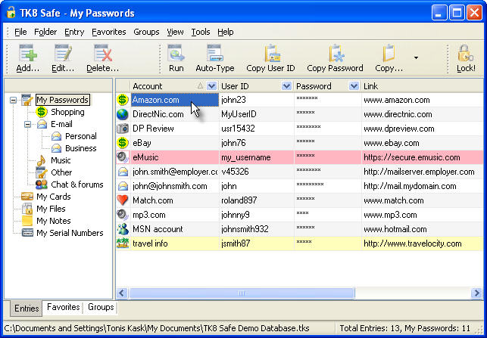
Firms should be careful, though, to ensure that employees only use this type of software for firm-related business. Staff that would be tempted to add their own bank accounts, credit cards or website log-ins, could open up the firm to risk, especially in the event of an SEC/FINRA type audit. But, at $19.95 for a personal version of the software, employees may wish to consider purchasing this for home use.

One final example involves the security of email communications. Much has been written about this subject. Yet, little is done to protect client information inside unencrypted emails. As an example, a financial advisor might email one of his clients with an attachment showing the clients net worth, list of assets, etc. This type of email is highly vulnerable. If you work with a broker/dealer, chances are there is an email solution already in place and available for use that has security features. If you are an independent advisor, it may be up to you to install a system to protect your firm and your clients private information. Encrypting emails is somewhat unwieldy as it requires the recipient to have the key to unencrypt the message. If you use MS Outlook as your email portal, for example, you would need to send a certificate file (.cer file) to the recipient, who then must add this to your contact record in their version of Outlook in order to see the messages that follow. For elderly clients or those unfamiliar with the internet and emailing, this could be cumbersome to say the least. The work-around is to avoid sending personal client data via email or to separate the data into several emails. Another choice is to add a secure lockbox (or vault) to your website and upload such documents there for client viewing). This method ensures encryption and password security. Most website providers for Financial Advisors provide lockbox or vault technology (i.e. www.advisorsquare.com, www.lightport.com, www.advisorsites.com )

Your choices for information security should reflect your need to protect your firm’s information as well as your client’s in a secure and efficient manner.

David Lawrence, AIF® (Accredited Investment Fiduciary™) is a practice efficiency consultant and is President of David Lawrence and Associates (DLA), a practice-consulting firm based in Lutz, Florida. DLA publishes a monthly subscription newsletter, “The Efficient Practice”, which focuses on operational efficiency. (www.efficientpractice.com) David is a much sought-after public speaker on a variety of leadership, financial and technical topics. For details, visit www.davidlawrencespeaks.com.

