Cost Controls: An Exercise in Belt Tightening
By David L. Lawrence

For those advisors who are fee-only or fee-based (or those with ongoing, asset based revenue), a reduction in the financial markets can translate into a reduction in gross revenue to the firm. 2008 is proving to be a challenging year in this respect. With stock market declines, mortgage woes, higher fuel and food prices, advisors and clients are likely to feel the pinch. The question is what can be done to stabilize net profitability in such an environment. The answer may lie in how a financial practice accounts for its productivity and expenses.

Cost controls applied to a financial advisor’s practice can embrace a number of different disciplines, from quality control studies to Six Sigma practices. With respect to the latter, Six Sigma is a set of practices designed to systematically improve processes by eliminating (or, at least minimizing the negative impact of) non-conforming product or service offerings. Applied to financial service firms, this might utilize a set of basic methodology steps identified as DMAIC:
- Define the process improvement goals that are consistent with client needs and firm strategy
- Measure the current process and collect relevant data for future comparison
- Analyze to verify the relationship or causality of factors. Determine what the relationship is and attempt to ensure that all factors have been considered
- Improve or optimize the process based upon the analysis using techniques such as workflow study comparisons (comparing the same process performed by different people in your firm)
- Control to ensure that any variances are corrected before they result in profit dampening. Set up and run oversight procedures and measure control mechanisms to ensure consistency
Though the specific techniques of Six Sigma go way beyond this simple acronym, it serves to illustrate the systematic approach to address process management in your firm. The term, Sigma, is derived from the statistical function of standard deviation. In a cost control study, Sigma typically refers to the number of standard deviations between the average time (for example) to complete a particular process and the nearest process specification limit.

To illustrate, let us say that to input a financial plan by an employee of a firm, management assumed that it would take, on average, about 3 hours to complete the data inputs. But in studying a firm with several employees who are responsible for such a task, it became apparent that most of the plans were taking about 4 hours to input. In a statistical bell curve, the study of this might look as follows:
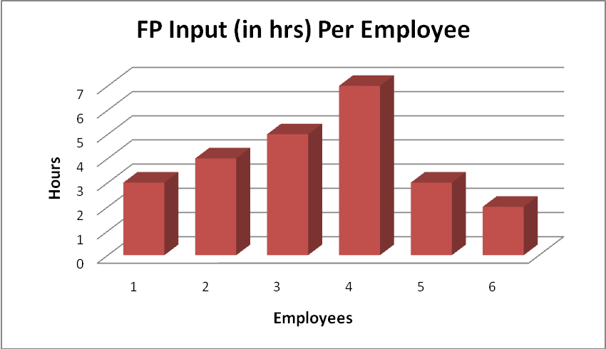

This chart reveals that most of the time, the data inputs seem to be accomplished in or around 4 hours. However, there is one employee who manages to get the job done in 2 hours and another who took nearly 7 hours to complete. Certainly, this would be valuable information to the owner of the firm as it could uncover a highly efficient employee (or one who is cutting too many corners) and it could also uncover a training opportunity for that employee who is identified as taking too long to get the job done.

Another application of this chart is in identifying the norm or average time to complete a task. If a task takes, on average, 4 hours to complete, then the firm has a basis upon which to objectively determine the productivity of a particular employee as it relates to a specific workflow task. It also permits the firm to set limits on what is deemed acceptible performance (perhaps, in this illustration a range of 3 -5 hours). Anything outside that range might be cause for management concern.

The overwhelming reason to embark on such studies is to determine if the firm is getting the biggest bang for the buck, so to speak. Does it make sense to pay two employees the same where one takes twice as long to complete the same set of tasks? Does it matter to the firm if the employee who takes half as long to complete a task is making so many mistakes that, ulimately, it takes longer to finish due to corrections and/or management intervention.? These are the sorts of questions that cost control studies can answer.

The cost to a firm of not doing this type of study could be enormous. The effect of losing 6 hours per week per employee in a 6 employee staff pool with an average wage base of $35,000/year, could be costing that firm over $30,000 a year. That is almost the salary of another employee.

As valuable as cost control studies are, they are difficult to implement in an impartial way. There are essentially two methods to implement cost-control studies: surreptitiously, using transparent management reporting techniques, or overtly, using micro-management techniques (not recommended). The problem with overt methods is the bias that could be applied to the study. Employees who know they are being studied may alter their normal routine to conform to some perceived idea of what is expected, rather than what they are actually doing on a regular basis.

There are many ways, however, to implement transparent management techniques to cost control studies. One obvious choice is in the client relationship management software that the firm may use. Depending on the software developer, there may already be a set of customizable management reports that permit viewing what the firm’s employees are doing. Such solutions as Interactive Advisory Solutions (www.IASsoftware.com) which has robust office workflow management tools, Junxure (www.gowithCRM.com) with its heralded actions management and customizable reporting capabilities and ProTracker Advantage (www.protracker.com), that has a completely separate employee scheduling and workflow management capability inside its client relationship platform are examples of existing systems that can be used for cost control studies as it relates to processes and employees.

Another potentially expensive area of cost is in office clutter. (see February 2008 issue, Financial Advisor Magazine) Office clutter creates lost time in finding stuff and processing paperwork, which can quickly and significantly add to the bottom line of expenses. Consider if you spend a minimum of one hour each day in the handling of clutter. Over the course of an entire year, if your time is valued at, let’s say, $175 per hour, could be costing you upwards of $43,750. (1 hour x 5 days a week x 50 weeks x $175) This is lost time that could have been used for other purposes, such as meeting new clients, servicing existing clients, or simply working on useful pursuits in the office. Because office clutter is such a benign element in the office, it is rarely recognized for what it truly is, a monumental time demander and profit drainer.

No cost control study would be complete without a thorough understanding of the pricing versus cost relationship of each product and/or service offering by the firm. Net profit recovery is a process of understanding that relationship and making adjustments in pricing to reflect reasonable profit amounts above actual costs incurred. The following chart is a simplified example of this:
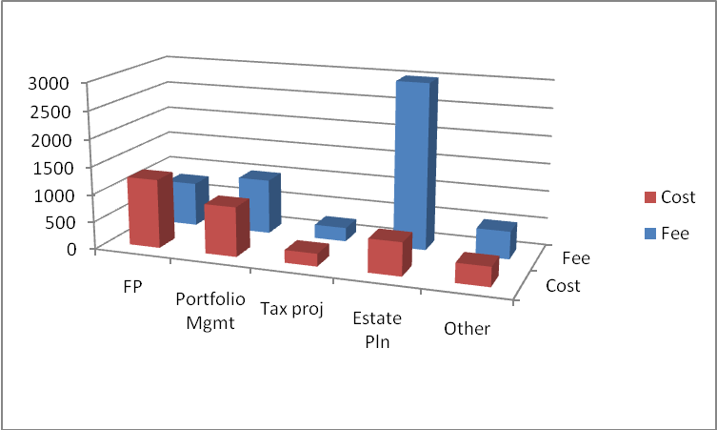
Though this is a chart based on fictitious data, it shows how such a tool could reveal inequities in a firm’s pricing mechanisms.

The purpose behind cost control studies is to uncover and recover verifiable cost savings, increase productivity of staff and, ultimately to improve client service. In a declining gross revenue environment, it may still be possible to sustain net profitability with such studies. An example of this follows:
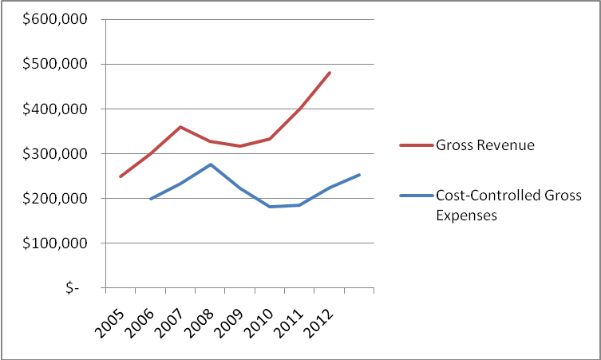
As can be seen from this chart, there is a slight lag in the response to declining revenue in or around 2008. However, by applying cost control techniques, profitability is re-established and maintained. The eventual result is that when gross revenue again trends upward, the firm is poised to take greater advantage of this on a net profit basis.

David L. Lawrence is a practice efficiency consultant and is President of David Lawrence and Associates (DLA), a practice-consulting firm based in Tampa, Florida. DLA publishes a monthly subscription newsletter, “The Efficient Practice”, which focuses on operational efficiency. (www.efficientpractice.com) David is a much sought-after public speaker on a variety of leadership, financial and technical topics. For details, visit www.davidlawrencespeaks.com.

