The Migration of Wirehouse Brokers to the Independent World

By David L. Lawrence, AIF®

There are, arguably, hundreds, perhaps thousands of wirehouse brokers either shifting or contemplating a shift from the wirehouse world to the world of the independent advisor. There may be a variety of reasons for this shift, not the least of which is a perception of what impact recent rulings have on the advisor/client relationship. Being asked to disclose, for instance, that recommendations made to a client may or may not be in the client’s best interests (and, potentially in the interests of that advisor or firm) would appear on its face to be counter-productive to the advisor/client relationship. Added disclosure requirements in the wake of the controversy surrounding the so-called “broker/dealer or Merrill Lynch rule” are intended by the broker/dealer firms to indemnify that firm again potential litigation claims and to some extent, to protect the advisor. However, it may be creating the unintended effect of alienating those advisors in the wirehouse and/or corporate broker/dealer environment who yearn for a simpler set of rules under which to operate and serve the needs of their clients.

For the broker, working in a corporate environment in which the firm is a manufacturer of products (IPOs, Mutual Funds, etc.) and gains its greatest profits from such products and not necessarily from broker-driven transactions, is a potential conflict of interest issue and tends to minimize the importance of the broker to the firm (in the view of the broker).

Consequently, a large number of senior wirehouse-type brokers are either moving or contemplating a move into the independent advisor world. With this move, comes a unique set of challenges for that former broker, not the least of which is a fundamental change in the relationship with his/her clients. Structurally, being an independent advisor is fundamentally different from living in the wirehouse and/or corporate broker/dealer environment. If that former broker chooses to pursue an independent Registered Investment Advisory (RIA) practice, there is the question of where to house client investments. There is also the challenge of retooling the advisor operations to conform to Federal and State requirements (ADV filings, etc.). And, there is the issue of the offering of advice, through either a fee-based or fee-only operational structure.

Fortunately, there are plenty of resources for these people to turn to. We might begin by examining a three-step process:
- Step 1 is to create a fundamentally sound strategic plan for the new advisor practice. Using a competent third-party consultant during this phase is a good idea, if affordable as it may help to have the benefit of an objective viewpoint from someone who has helped others do essentially the same tasks. In interviewing such a consultant, it is always a good idea to inquire about his/her experience in working with others that share your situation and needs.
In this strategic planning step, it is important to define the scope of operations, the style of practice, the direction (vision) of the firm and the specific, measurable goals and objectives for that practice. Consider the following Affinity Diagram for a firm that seeks to understand the complex interrelationship of various operational elements within a firm and translate that into a strategic picture of the firm.
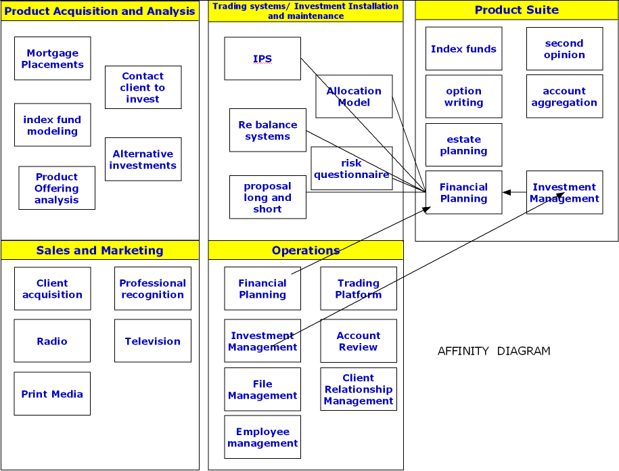
Using this type of exercise can help to define and translate the strategic plan into an operational model.

For the purpose of implementing such a plan, comparison to different investment management providers is suggested. As an example, there are two distinct choices to consider. The first is to work with an outsource provider that can help you develop and manage your investment practice. FocusPoint Solutions (www.focuspointsolutions.com) is a good example of this type of provider. Offering a turnkey service to those advisors that wish to migrate into the independent world, but retain the high level of support associated with a larger firm environment, FocusPoint offers a host of services designed to meet that unique set of needs. The second choice might be a traditional provider of warehousing and clearing services, such as that offered to independent advisors through Schwab (www.aboutschwabinstitutional.com/) or TD Ameritrade, formerly TD Waterhouse, (http://www.tdainstitutional.com/goindependent/breakaway.htm).

- Step 2 might be setting up the legal and compliance aspects of your new practice. For this, working with a third-party consultant that specializes in such services as ADV filings, compliance consulting, etc. would be of invaluable assistance. Developing an acceptable ADV that fulfills legal requirements while properly disclosing the unique aspects of what your firm provides to its clients is a complex task. Without experience in developing an ADV, it could become an expensive, lengthy and frustrating process to attempt in on your own. Using a dependable source to help develop this vital aspect of an RIA practice can save money, time and frustration. One such firm that keeps being mentioned is a company in New Jersey called Market Counsel (www.marketcounsel.com). Because helping individuals and firms become independent RIAs and then supporting those firms with compliance-related services is all that Market Counsel does, it is apparent (from interviews with their clients) that they have become very efficient at it.
- Step 3 involves the integration of an advice channel into your product and service offerings. For the migrating wirehouse broker, this could be virgin territory. Many former wirehouse-type brokers lack experience in advice for a fee, much less developing a pricing and operational model for such services. The following chart might serve to illustrate the complexity of integrating such service channels with the efficient use of staff:

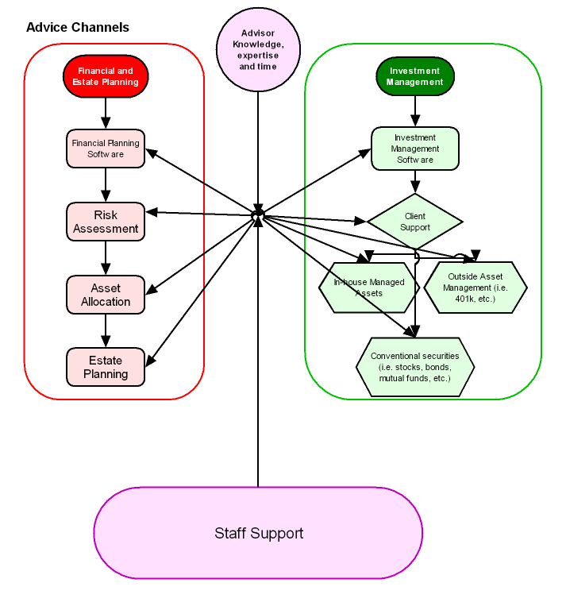
One of the most critical aspects of this step is determining your pricing model. It should be based on obtaining a reasonable profit for your services relative to the cost to your firm of providing those services. As the above chart illustrates, determining the cost to the firm could be difficult, depending on to what extent employees are used in the production of the advice channels. Other factors, among them office rent, equipment leasing, paper and ink costs, telephone, website, fax, electric, cell phone, email, software licensing and marketing expense (to name a few), must also be considered in that pricing model. And, most importantly, your time as the advisor must be considered. Many firms have adopted pricing structures based on a perception of what they think the client will be willing to pay. If it is too low, which it often is (see “Is the Price Right? By Tracey Longo, Financial Advisor Magazine, November 2006), the thinking is that it can be made up on the asset side. The problem with this line of thinking is the message being sent to clients that advice is secondary in value to the management of assets. Another problem is offering services that are, by their pricing, providing a negative cash flow (or drain) on the practice. Being paid properly for your background, experience and time sends a very positive image to your clients, regardless of the actual dollar amounts involved. It says that you recognize the value you bring to a client’s financial situation and needs and you expect to be paid appropriately for that value.

For the migrating wirehouse-type broker, this may be a steep learning curve. Unfamiliarity with the ‘advice for a fee’ aspects of a financial practice could result in some discomfort with imposing large fees for such advice. But, for those brave souls who undertake this migration, the result could be well worth all the effort.

David Lawrence, AIF® (Accredited Investment Fiduciary™) is a practice efficiency consultant and is President of David Lawrence and Associates, a practice-consulting firm based in Lutz, Florida. (www.efficientpractice.com) David Lawrence and Associates offers a variety of consulting services including operational and technology consulting related to the financial planning process and investment management.

