Managing Your Employees – a Holistic Approach

By David L. Lawrence, AIF®

In a profession fraught with increasing profit pressures, finding time to manage employees can be more than just a simple challenge for financial advisors. For some practitioners, management takes the form of damage control, rather than a well-thought out pro-active approach to the oversight of employees. At the other end of the spectrum, micro-management can be found. Both of these approaches are usually inefficient, unprofitable and lead to further problems. One solution is to take a systems approach that is holistic in nature, offering efficient management techniques within an environment that fosters individual employee growth. To understand the application of such a solution, let us look at a couple of hypothetical examples.

Example #1: In this first hypothetical example, we have J & J Financial Services, a full-service financial planning and asset management firm with two full-time employees and one part-time employee. John J., the principal operates a Registered Investment Advisory (RIA) Firm that is also affiliated with an independent Broker/Dealer. Owing to the dual nature of the business, the firm is subject to SEC compliance procedures along with NASD and B/D compliance rules that have placed a great burden on employees from a paperwork perspective. To try to counter the enormous compliance demands, the firm has purchased scanning equipment and indexing software to convert all client files and other compliance-oriented files to electronic form, as much as possible. With a ten-year backlog of paper files to convert along with some 800-client files in multiple folders and in different locations, the unintended effect was to put an enormous additional workload on the employees to perform the file conversion while being expected to continue to keep up with their other daily duties. The file project was “sprung” on the employees with no advance warning (a common occurrence according to the employees) and with little or no training on the new scanning procedures. The result was uncontrolled chaos and employee resentment.

At this point, the principal, John had to step in to perform damage control. Decisions had to be made to cut down on the workload for his employees; decisions that would likely cost the firm money and delay the process of conversion. Moreover, he had to deal with disgruntled employees. The irony is that all of this could have been easily avoided with a systematic approach to management of employees that involved more than the immediate needs of the firm. (In other words, a holistic approach)

Example #2: In this second hypothetical example, we have Pro-mark Wealth Advisors, an RIA firm that has no NASD registrations (independent). Pro-mark has 8 employees and one principal, Markus L. Pro-mark does tax preparation work in addition to wealth management. The firm deals mainly with retired clients who have investable assets that exceed $1 million dollars. Markus has a ten-minute egg timer placed prominently on his desk. He explains that during the course of his daily activities, he turns the egg timer. When it runs out, he gets up from his desk (interrupting whatever he is doing including the possibility of a client appointment) to walk around to each of his employee’s desks to see what they are working on. To him, he sees this as a visible sign of his commitment to support his employees. To the employees, he is an insufferable micro-manager who is so paranoid that he cannot keep his hands off the wheel for even an instant. The problem extends to more than employee dissatisfaction (which in this case results in a 50% annual employee turnover rate). Clients are allowed to see this going on which negatively influences their level of confidence in the firm (and the likelihood of referrals). Micro-management has also affected time management for Markus, the principal “rain-maker” for the firm. With such a demanding detail-oriented schedule and virtually no task delegation skills, there is precious little time to generate new clients. The result is an inefficient and unprofitable firm.

Both of the above examples could be positively impacted using a holistic approach to management of employees. The question is, what is this holistic approach and how can you integrate it into your firm? To answer that question, consider the following chart:
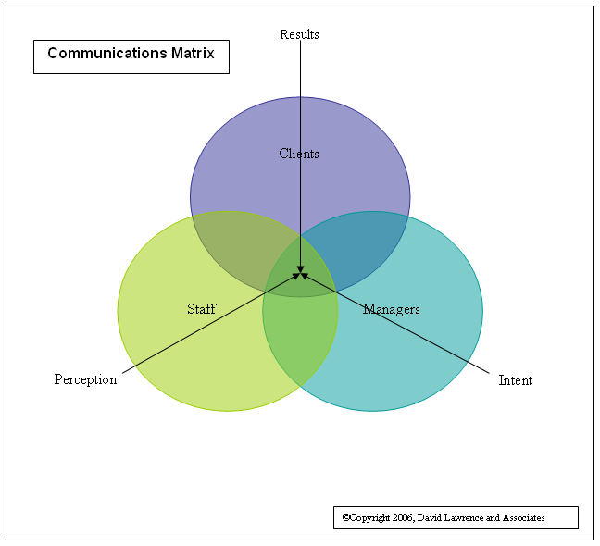
The above chart illustrates an important point about communications that relates to a holistic view of your practice. Enacting a decision in your practice without considering the effect it may have on others can have unintended negative impact on your practice from a variety of perspectives. In the above chart, your intent in communications must match the perception of those receiving the communication in order to achieve the desired result. Often, practitioners are in such a hurry to “get the job done” that they neglect to take the time to ensure that what they meant to say is what is actually heard. This is the first phase in developing a holistic management process. (Communication)

The second phase is to turn your employees into stakeholders. If they have a stake in the success of your practice, they are much more likely to support your decisions on the firm that could favorably affect them as well. Building stakeholder relationships with your employees based on trust can be a powerful way to increase the efficiency and profitability of your firm. This can be accomplished in a number of different ways, including tying compensation, bonuses, etc. to firm profitability.

The third phase is to develop an employee management process that is objective, fair, reasonable and fully understood and agreed to by your employees. This is easier said than done. One way to approach such a process is to develop job outlines; detailed outlines of position responsibilities, expectations and behavior that is consistent with the overall vision, mission and/or goals of the firm. Once developed these can then be dually used as a means of identifying and training employees and as a means of evaluating the performance of those same employees, using the same objective criteria described in the position outlines. The employee management process then becomes a three-step system as illustrated below:
Step one:
Position Outlines

Step two:
Observed performance and behavior

Step three:
Evaluation and feedback of performance and behavior

By developing the position outlines as a minimum set of acceptable expectancies, you do not limit yourself to what you may ask of an employee. You merely set up a process to evaluate that employee on an objective (rather than subjective) basis.

By following these criteria, it is much easier and less risky to reduce the micro-manager’s stranglehold on the firm and to allow employees to take on additional responsibilities with less managerial oversight.

Workflow management should be fully integrated into this process. Assigning tasks, being able to track task completion, both from an efficiency and proficiency standpoint, and effectively handling task delegation should be seamlessly wrapped into the employee management process, taking into account the motivations and skill sets of the employees measured against the needs of the firm. The results will undoubtedly speak for themselves in increased productivity and profitability along with greater client and employee satisfaction levels.

David Lawrence, AIF® (Accredited Investment Fiduciary™) is a practice efficiency consultant and is President of David Lawrence and Associates, a practice-consulting firm based in Lutz, Florida. (www.efficientpractice.com) David Lawrence and Associates offers a variety of consulting services including operational and technology consulting related to the financial planning process and investment management.

