**Another Efficient Tool for the Remote Advisor**

By David L. Lawrence, AIF®

Some advisors have developed nests of clients in remote locations from their main office. This may have been by design or it could possibly be as a result of clients’ referrals, clients moving to another location or other client acquisition techniques. Though, having nests of clients can provide a firm with expanded revenue opportunities, it also poses significant technological challenges.

One of the challenges is reliable access to files and information while “on the road.” If you are the owner of a so-called ‘Smartphone’ such as a Treo, Blackberry or similar, then you are familiar with synchronization software. Most of these devices either use Microsoft’s Activesync software, Palm’s Hotsync software or something similar. If you are familiar with these, you may also be familiar (or frustrated by) their almost universal lack of flexibility. To synchronize files and/or information between a desktop machine and a laptop could involve a two-step process: sync’ing the Smartphone first and then resync’ing with the laptop. Even then, not everything gets updated. Only certain files, usually associated with the software and/or functionality of the Smartphone, get synchronized. If Microsoft Outlook is the email software of choice, generally the schedule, contacts and notes are transferred, but not necessarily the emails.

Other files, such as financial plan output documents, hypotheticals, investment reports, etc. do not generally get included in the updates. Thus, some advisors have chosen to use a remote access software solution such as GoToMyPc.com. Despite the reliability of the platform, it is often slower and more laborious to answer emails through the same web connection as your remote access. (Bandwidth is typically cut in half). One workaround is to use a version of your email program on your laptop to read emails, while creating settings that preserve a copy of the email on the email host platform. But, even this can be inefficient as it could create a huge backlog of emails to wade through once you return to your office desktop.

So, the question remains as to what other choices might be available. On November 8, 2007, Siber Systems, Inc. announced the release of GoodSync Version 6, the latest version of its award-winning data backup and synchronization product.  Despite a simplicity and power that has earned it top praise from Computer Shopper, Network World and various other computer magazines and software Web sites, Version 6 has become even faster and easier to use, thanks to a slick new graphic interface and an improved synchronization algorithm proven capable of syncing a million files at once.

GoodSync allows users to synchronize data between any two PCs or storage devices, in any direction.  Backups and synchronizations can be accomplished via USB cable, over a home or workplace network, or even the Internet.  The highly advanced product automatically detects the latest file changes and deletions regardless of where the changes/deletions exist, then moves them to all other devices involved in the sync—a perfect tool for updating and transferring music, videos, work files, photos or other important information.

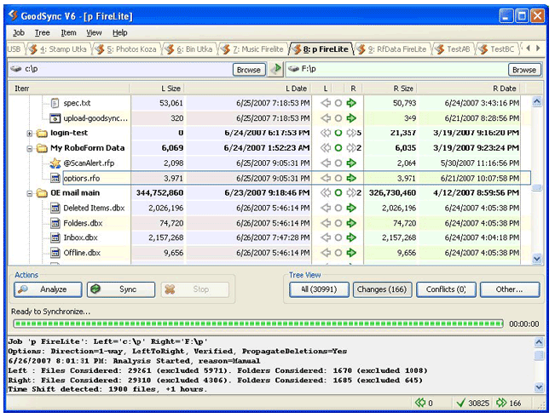

GoodSync Version 6 adds a number of new features that make it easy enough, yet robust enough for both home and business use.  User improvements in Version 6 include:

* A **new tree-based interface** that allows users to more easily view file changes;
* An **improved file status display** that shows files matched, files unmatched and sync direction;
* **Advanced automatic settings** that allow complete set-it-and-forget-it flexibility;
* **Easy job setup** witha tabbed display that facilitates switching between multiple jobs;
* **Improved first time help messages** offered through pop-up balloons;
* An **online, step-by-step tutorial**; and
* Now available in **12 languages**.

The user interface has just two main options, Analyze and Sync, making the software easy for beginners, yet very robust for advanced users and tasks.  There are also automatic settings, help balloons, an online tutorial, the ability to sync a million files at once, *plus* a free trial offer.

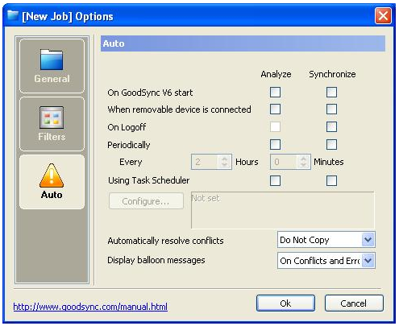

Larger firms have discovered the enterprise-class backup performance of GoodSync.  Version 6 offers a host of features that add to GoodSync’s appeal, including automatic settings that enable GoodSync to periodically perform backups throughout the business day without affecting worker productivity.

To simplify synchronization tasks, syncs can be set to run automatically on logon or logoff using an AutoSync setting; what’s more, GoodSync can be set up to automatically save a copy of a file that GoodSync is about to replace when syncing, ensuring that the last two versions of any file are maintained for recovery if needed. For those practitioners concerned with Sarbanes-Oxley compliance with offsite storage and retrieval solutions that are cost-effective and efficient, GoodSync might just be the right solution.

The good news is that this innovative data backup and synchronization utility is FREE for personal use; a professional version of the product can be purchased for $19.95 (USD), with Enterprise and OEM pricing available.  GoodSync Version 6 is now available for download or purchase at [www.goodsync.com](http://www.goodsync.com/).

**David Lawrence, AIF® (Accredited Investment Fiduciary™)** is a practice efficiency consultant and is President of David Lawrence and Associates, a practice-consulting firm based in Lutz, Florida. **(**[**www.efficientpractice.com**](http://www.efficientpractice.com)**)** David Lawrence and Associates offers a variety of consulting services including technology consulting related to the financial planning process and investment management.