Integrated Advisor Platforms: Using the One-Stop Shop Approach

By David L. Lawrence

There is something to be said for simplicity. In a profession that has become increasing more intricate and technology driven, finding simple solutions to complex problems can be difficult. There is, however, an emerging trend among software providers that could provide simplicity to the management of assets and operation of your practice.

For years, advisors have struggled with the use of divergent software packages that simply do not speak to each other. The resulting inefficiency created by having to enter the same information multiple times is obvious and often frustrating to the advisor and his/her staff. The issue for software manufacturers appears to be the reluctance to release proprietary software code needed to integrate outside software into their products. Certain software deals have emerged (notable examples are NaviPlan’s Web-based Naviplan Central (www.naviplancentral.com) and its ability to snatch data from Albridge Solutions and dbCams has made a concerted effort to permit exchange of data with other software programs (www.dbcams.com), along with Morningstar’s Advisor Workstation, among others). However, the trend is far from universal.

A new trend that does appear to be increasing in popularity is a web-based software solution that could be called an integrated platform. This type of platform combines several different functional softwares into a single operational platform that is capable of sharing a common database. Modules might include financial planning, client relationship management, portfolio monitoring and management, risk tolerance scoring, asset allocation and marketing to name a few.

The advantage of this type of platform is the efficiency in the use of information stored on that database. Presumably, information need only be entered once and then shared seamlessly with all functions of the platform. Cross-functionality permits easier archiving of complex tasks (history reports, linked information, email storage, etc.) For heightened compliance purposes, this type of platform could significantly reduce the amount of paperwork and effort required to keep up with current compliance rules.

One potential disadvantage of the integrated platform concept is the lack of choices available for the various functions it might perform. In effect, by choosing a particular integrated platform, you would be faced with using only the various features included in the platform. If, for example, you were interested in doing high-end wealth management services with cash-flow based estate planning software (on a par with Naviplan Extended, Lumen Systems FPP or Sawhney Systems ExecPlan), you would be limited in finding an integrated platform that contains such a feature.

For purposes of understanding this type of platform, four services have been selected as examples. Though there are undoubtedly many more than this available, these four should suffice to illustrate the various choices available.

The first is Thomson ONE Advisor (www.thomsonadvisor.com). Thomson ONE Advisor is billed as a complete wealth management solution for advisors that is designed to blend financial planning, comprehensive research, presentation and asset allocation products into a suite of workflow tools and shared data. Using the powerful real time data and research platform from Thomson that includes its long standing CDA/Wiesenberger hypothetical illustration software along with powerful portfolio management software and financial planning tools that share a common client database, this platform rivals Morningstar’s Advisor Workstation in functionality at a very attractive price. (Exact pricing was not available at press time, but is believed to be in the $150 - $185 per month range)

The second is Client Marketing Systems’ Advisor Assistant. (www.climark.com) Advisors Assistant is a comprehensive Contact Management System that helps you keep in touch with your clients to keep them from straying to other advisors. It also helps you organize your office, work more efficiently, and increase sales. Advisor’s assistant also has add-on modules for Portfolio management (requires downloads from other sources such as Schwab, TD Waterhouse, DST Fanmail, Pershing, Fidelity, Albridge, etc.), insurance management, commission tracking, remote access, paperless office and form automation. Clearly, this approach affords the practitioner choices in selecting only those modules that will best fit the needs of the advisory practice. A Single user license is $499 per year (for client management and policy tracking). However adding additional modules can quickly increase this cost.

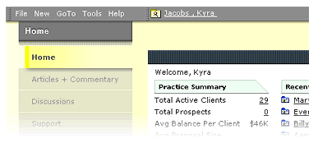
The third is Morningstar’s Advisor Workstation. (www.corporate.morningstar.com) Morningstar® Advisor Workstation is a Web-based software platform that integrates client and portfolio data with other desktop software. Available features include in-depth research and real-time delivery, robust and flexible client reports, portfolio management, goal-based planning, and asset allocation tools. Advisor Workstation creates an efficient working platform that supports an advisor’s practice. Available in both an enterprise edition and office edition, the Office Edition is intended for independent advisors. This integrated application includes an easy-to-navigate interface, customizable reporting and document capabilities, research tools and reports, and its newest feature, a contact management system.
Its financial planning resources include Monte Carlo simulations and an Efficient Frontier-based approach with Morningstar models, lists, and searches for portfolio optimization. Clearly, Morningstar has a robust interface and has added new features to keep up with the competition. At $5,000 a year though, it could be an expensive addition to your software lineup.

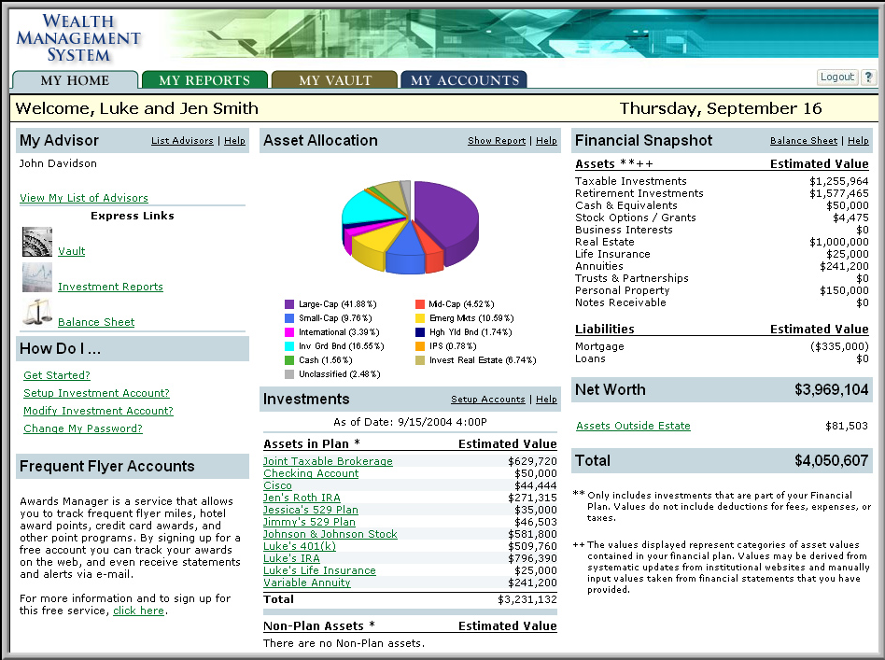
The fourth is eMoney Advisor’s AdvisorPlatform.
(www.emoneyadvisor.com) According to eMoney’s website, “eMoney’s AdvisorPlatform provides financial advisors with a web-based wealth-planning tool that offers an aggregated, comprehensive view of a client’s financial portfolio, as well as features and functions that enable more complete planning and better servicing of a client’s needs.
eMoney Advisor offers:
- Comprehensive Planning Center
- Goal Planning Modules
- Alerts and alarms that allow you to provide better service
- Account aggregation that provides a comprehensive view of your client’s portfolio status
- A Client Profile Grid that identifies areas for new revenue opportunities
- Role Based Permissioning for better delegation between advisors, assistants, and planners
- Alliance Partnerships to allow for collaboration with attorneys, accountants etc.
- An interactive interface that enables simplified account management
- Customized reporting capabilities to meet your client’s needs
- An online storage “Vault” that helps clients keep track of valuable documents

Pricing is $1,200 per year for the advisor license and $200+ per year per client according to Edmond Walters, Founder and CEO. Though, pricing could vary depending on the needs of the individual advisor practice. The financial planning area is 100% cash flow based and integrated with all other areas of the financial plan. This means that a change in one area of a plan could impact another area and will be immediately updated to show such effects. One unique aspect of EMoney’s platform is an alliance page where permission-based client data can be shared with other professionals for collaboration purposes.

Additionally, eMoney Advisor offers two other platforms for advisors, eMoney's AdvisorMarketing service equips advisors with a variety of tools to market and sell their wealth management services. These tools include customized CDs, brochures, PowerPoint presentations, advertising slicks, Web links and on-site sales and marketing training sessions, according to its website.
eMoney’s AdvisorAssurance™ module provides financial institutions with a means of lowering the risk associated with providing financial advice, while also improving enterprise workflow and reporting capabilities. Working in conjunction with their AdvisorPlatform™, the AdvisorAssurance module permits financial advisory firms to proactively manage their exposure and ensure that their advisors follow set standards. The company claims that AdvisorAssurance can help alleviate regulatory burdens.

If you use a broker/dealer, your choice may be determined by what is allowed by that B/D. Otherwise, these four illustrate the differences based on features versus cost. If financial planning tools are your main concern, eMoney Advisor appears to have the strongest offering among the four. The others contain financial planning tools and calculators. Thomson ONE is a clear winner in cost and Morningstar has robust portfolio management features. Advisor’s Assistant contains strong marketing and client management features. Your choice should be based on what is most efficient given the needs of your practice.

David Lawrence is a practice efficiency consultant and is President of David Lawrence and Associates, a practice consulting firm based in Lutz, Florida. (www.efficientpractice.com) David Lawrence and Associates is an approved sponsor of CFP Board of Standards continuing education credits and offers CE programs on a variety of topics, including the financial planning process.

