Efficient Communications in a Financial Advisory Practice

By David L. Lawrence

One could argue that a key element of efficiency is effective communications in the workplace. Yet, the skills as a communicator necessary to be an effective financial advisor are quite different from the skills needed to communicate with staff in a managerial sense. This is because there is a difference between using communications to persuade people versus using communications to build team relationships. For this reason, financial advisors who maintain staff may wish to consider approaching communications differently when they interact with their employees and/or co-workers.

In a recent visit to a financial advisory firm, several mis-steps in communicating were observed. First, the firm has partners, consisting of senior financial advisors; managers, who oversee staff and operations; and, a sizeable number of employees. In this example, the partners might issue a request directly to a staff member or through one of the managers. If it is through the managers, it was observed that, frequently, the partner might go directly to a staff person with additional requests or to countermand a request with something more urgent. The problem in this case is the stripping of authority and the chain of command from the middle manager; giving them the job of assigning tasks and then going around them when it suited the needs of that partner. This particular firm lacked a consistent communications protocol and badly needed a strictly observed workflow system. The perception of the staff is that workflow is out of control and the partners could not relinquish control. The perception of the managers is that they have no real authority. But, the intent of the partners was to get the job done. The result, in this example, is a firm with low morale and little motivation to be there other than the paycheck. So, the question is, how do we fix this communications boondoggle?

As a start, one consideration is an old saying that ‘communications begin with the assumption of good intentions’. This goes to the heart of understanding; the difference between perception and intent. When communicating with someone in your office, you may have a very different intent in your conversation than what is ultimately perceived by the other person(s). This may be due to the type of conversation, the specific topic, your choice of words and/or your history in communicating with that person. Tonal inflections and non-verbal cues such as raised eyebrows or eye contact also add meaning to the conversation that could be mis-perceived.
This dilemma in communication is not limited to the financial advisor and staff. It can also affect your clients. To represent this communications dynamic, the following chart applies:
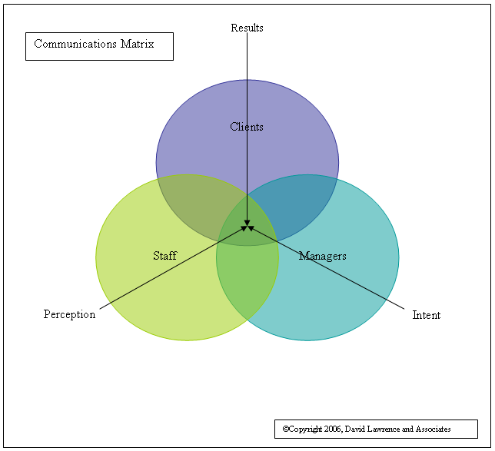
The above chart illustrates the spillover effect of combining perception with intent to create results. There is a clear overlap or communications intersect that must be considered in communicating as a manager of people. And, clearly, it can have either a positive or negative impact on your clients depending on how successful you are in matching your intent to your staff’s perception of what you said.
Another aspect to consider is the form of communication. Differences exist in communicating by phone, email, letter, note or in person. Often a poorly worded email, for instance, can create as much misunderstanding and/or confusion as a conversation in person. Sometimes more confusion could exist with email communication owing to the lack of other visual cues for meaning that might be associated with reading someone’s facial expressions, demeanor, etc. (use of emoticons, those little smiley faces, is discouraged in business communications)

Consider these five rules of communication that can be used to avoid communications problems.

- The first rule of communication is the assumption of good intentions
- The second rule is to develop communication partners – by developing co-communication partners you have the ability to strengthen the message with support from a second person. This person may be a partner or other manager in your firm. By both of you being ‘in sync’ on the message, the message carries more weight.
- The third rule is to practice listening for intent – The key to good managerial communications is to develop good listening skills.
- The fourth rule is to avoid jumping to conclusions – Give your staff the benefit of the doubt.
- The fifth rule is to confirm communications by restating them and/or asking for clarification.

These are simple rules that could potentially save hours of wasted time and effort created by mis-communications. Efficient communications depend on proper understanding and accurate perception of intent.

When communicating with staff and/or co-workers it is important to resolve conflict immediately. If a conflict arises over mis-communication or mis-understanding of intent, it is critical to confront the issue quickly. Do not let the problem fester. It can become a cancer on your financial practice that taints other areas of the practice including, but not limited to your staff’s relations with your clients.

It is also important to make a commitment to good communications. It is your responsibility to set the example. Show that you have a passion for getting it right the first time. People in a position of management responsibility have to be chameleon-like in their communications techniques. That is, you have to be able to adapt to the style of communication that the person you are communicating with will find easiest to understand. With one person, use of crude humor (for example) might be viewed as endearing and funny, whereas another person could easily be offended. Use of humor as a communications device can often backfire. If you insist on using humor, self-deprecating humor is usually best.

Speed is another issue. Most people talk at about the same rate with which they listen. Therefore, if you talk fast and you are discussing something with a staff person who talks slow, you will need to slow down your speed of speech so that your listener(s) can process what you are saying. Conversely, if you talk relatively slow (deliberate) and your listener is someone who talks faster, chances are they will become easily bored by what you are saying, regardless of its importance. In this case, you may need to force yourself to talk faster to match their ability to assimilate the information and keep their attention. Leaders need to have the skill to change their communication style to match the recipient’s style of speech.

Consistency is another key to good communications. Changing the game plan every five minutes is frustrating and de-motivating to staff. If you are the type of boss that likes to try new ideas for operating your practice, first consider the impact on current operations and the effect those ideas will have on your staff before throwing them a curve ball.

Your staff is not unlike your clients in that they will not care how much you know until they know how much you care. One of the most effective ways to demonstrate your commitment to excellence is through your passion for communicating efficiently.

David Lawrence is a practice efficiency consultant and is President of David Lawrence and Associates, a practice consulting firm based in Lutz, Florida. (www.efficientpractice.com) David Lawrence and Associates is an approved sponsor of CFP Board of Standards continuing education credits and offers CE programs on a variety of topics, including the financial planning process.

